Week 1 – Yujie Hu

Github URL - <https://github.com/garyhu537/FIT5032.git>

Task 1.1

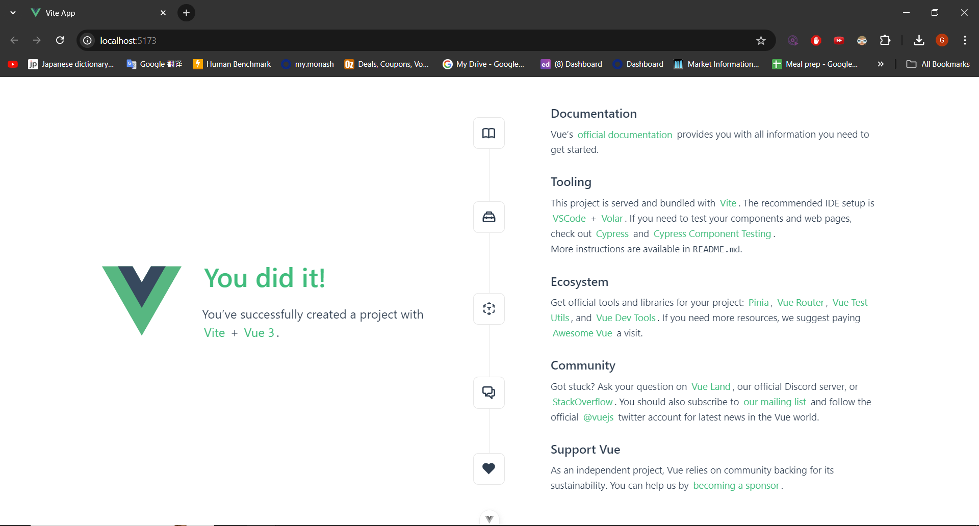

Task 1.2

